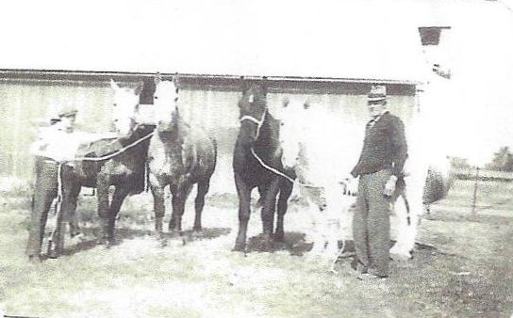

**Wolfe men and their horses**

**Worthen and Related Family Ancestors**

|  |  |
| --- | --- |
| **C:\Users\Richard\Documents\Family Tree Maker\Book Material - Wolfe\Mary Jo material - early Jan 2014\2014-01-16\013g.jpg**  **Jeremiah Morris**  **father of Elizabeth Morris** | **C:\Users\Richard\Documents\Family Tree Maker\Book Material - Wolfe\Mary Jo material - early Jan 2014\2014-01-16\013h.jpg**  **Agnes Moore**  **mother of Elizabeth Morris** |